rmwb_horizontal_reverse.airmwb_horizontal_reverse.ai

SAPRAE CREEK NEWSLETTTER

MARCH 2018

**www.rmwb.ca**



# SAPRAE CREEK RESIDENTS SOCIeTY

215 Freestone Way

Fort McMurray Alberta

T9H5B4

AnnMarie Hintz, Chair 780-881-2958

Tracy Unger, Vice Chair 780-743-3660

Tanya Poulin, Secretary 780-715-6867

Marilyn Rustad, Treasurer 780-715-4960

Keith Finnson, Infrastucture 780-799-0230

Brittany Ianetti, Youth Director 780-881-4061

Erin Fleming, Rec Director 780-799- 1808

Jennifer McQueen, Municple Contact 312-622-5172

**Email: sapraecreek@gmail.com**



# Contact Information

**Ward 3 News**

-2

-3

4-7

8-11

-12

Contact Information

Councillor Report

RMWB News/Notices

Community Corner

Community Calendar

# Inside this Issue

Editor: Joanne Clark

Phone: 780-714-0316

Email: [joanne.clark@rmwb](mailto:joanne.clark@rmwb)

April Newsletter Deadline:

March 23, 2018

Subscribe to your newsletter @

[www.sapraecreek.com](http://www.sapraecreek.com)

Check us out on FACEBOOK

Saprae Creek Residents Society



Municipal Switchboard

1-800-973-9663

RCMP

780-788-4000

By-Law/Animal Complaints: 780-788-4200

Pulse Line: 780-743-7000

Fish & Wildlife: 780-743-7200

SPCA: 780-743-8997

Health link: 811

For Septic Services: Call Andrew March @

Day Time: 780-799-5617

After Hours: 780-598-3997

**All EMERGENCIES 911**

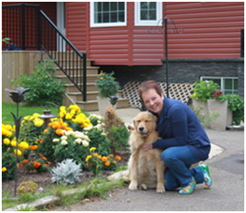**Councillors Corner**

March 2018

Wow, what a month February turned out to be! Aside from the bitterly cold weather here and in South Korea, the Alberta Winter Games and the Olympics proved to keep us busy and cheering for our local athletes. For such a small community, we are blessed to have two athletes in the Olympic games…Way to go Graeme Killick and Brooke Voight!!!!!

It’s been busy for me as well. We’ve made some cuts in the RMWB budget by 29.5 million and paid 65 million on the debt without cutting services, now we just have to pass it at the February 27, 2018 council meeting. I think we’ve got the coke dust under control; although having to escalate it to Suncor and CN ‘s head office isn’t acceptable. Bylaw is keeping on top of it and I’ve requested a meeting with the Minister of Health and the Minister of Environment when I attend the AAMDC conference in Edmonton at the end of the month. I want to bring them the MSDS sheets and some pictures to get their attention. Hopefully, that will bring attention to the issues we’ve been dealing with regarding the coke.

I have another meeting of the Energy and Infrastructure board on the 9th of March and now that the orientation for new members is over, I’ll be learning lots. I’ll report back with the highlights next month.

Just a reminder that the horizontal drilling will be starting soon and to be aware of the crews working in our neighbourhood. I know that just before Christmas, there were some water outages and extended repair times, I was told that there is a plan in place so that shouldn’t happen again. If your home experiences an outage and the crew is working nearby, please call the pulse line 780-743-7000 and report it, or run out and let the boys know that you’ve lost water so they can get it repaired quickly.

Until next month

Sheila



**CONTEST RULES**

By entering you agree to abide by all contest rules, and to have fun.

* Limit of 2 entries per person, per category. No Photoshopping/editing.
* Entries will be judged the first week of April 2018 and winners announced by mid-April 2018. Winning entries will be selected by Government of Alberta employees representing a

variety of ministries.

* By entering this contest, you agree to allow the NADC to use your name and photograph(s) in its promotional publications, on its website or in other online forms such as social  media sites. Any photo submitted may be shown throughout the contest on NADC’s social media posts.
* You agree to allow your photograph to be cropped or otherwise altered to fit into promotional publications.
* If entering a photo of a person or people, you must provide a signed release from any recognizable individual. Release forms are available a[t www.nadc.ca](http://www.nadc.ca/)

* Photographs must be taken within the NADC boundaries, see above or find the boundary a[t http://www.nadc.ca/nadc-map.asp.](http://www.nadc.ca/nadc-map.asp) • Entries must be received on or before midnight April 3, 2018.

* The photo must not have been submitted to any other photo contest.

**To Enter the Contest:**

Complete a contest entry form which is available at [www.nadc.ca,](http://www.nadc.ca/) and attach with the submitted photo(s). The personal information that you provide to the NADC will be used for the

purpose of administering this contest. It is collected under the authority of section 33(c) of the *Freedom of Information and Protection of Privacy Act (FOIP)* and is protected by the privacy provisions of the Act. If you have any questions about the collection of this information, please see the contact information identified below.

Please send original digital pictures in either .jpeg or .bmp format – it must be able to print clearly as an 8x10 print. Try to keep the pictures under 4 MB.

Email: nadc.council@gov.ab.ca Phone: 780.624.6274

Mail disc with digital pictures to: Northern Alberta Development Council

 9621 – 96 Avenue,

Bag 900-14

Peace River, AB T8S 1T4

Or drop off at our office in Peace River: 206 Provincial Building on 9621 – 96 Ave.

**Property Assessment Notices for the 2018 Tax Year have been mailed to all property owners in the Regional Municipality of Wood Buffalo.** The property assessment reflects market value as of the legislated date of July 1, 2017.



**IMPORTANT**

**MESSAGE FOR**

**PROPERTY OWNERS**

Please take some time to review your Property Assessment Notice carefully.

**Have questions or concerns about your property assessment?**

Call 780-743-7900 or 1-800-973-9663 to speak with an assessor. Assessors will be available 8:30 a.m. to 4:30 p.m., Monday to Friday, to speak with property owners. You can also visit our website to review the frequently asked questions about property assessment.

If you are still concerned with your assessment after speaking with an assessor, you can file a complaint with the Assessment Review Board. All complaints must be submitted by 4:30 p.m. on Monday, April 30.

**What happens next?** Council will set the 2018 tax rate in May. Property taxes are determined by applying the approved tax rate to the assessed value shown on your Property Assessment Notice. Property Tax Notices will be mailed in May.

|  |  |  |  |  |
| --- | --- | --- | --- | --- |
| **ASSESSED PROPERTY VALUE** | **x** | **PROPERTY TAX RATE** | **=** | **PROPERTY TAX BILL** |

RMWB Online Payments NOW AVAILABLE!!

You can now pay your RMWB utility (water) bills, ambulance bills and general trade invoices online by credit card. Visit **pay.rmwb.ca** to learn more or make a payment today.







**THE HUB Parent/Child Program**

WHEN: Wednesdays

WHERE: Vista Ridge, Spruce Valley Room

TIME: 10-11:30

Geared towards ages 0-5, a great way for your child to socialize with similar aged children in Saprae Creek by way of interactive stations and craft time, followed by a light snack.

This is such a great program for families in Saprae when your oldest child(ren) is in school and you want to get the chance to get out of the house once a week and meet some fantastic people in our community.

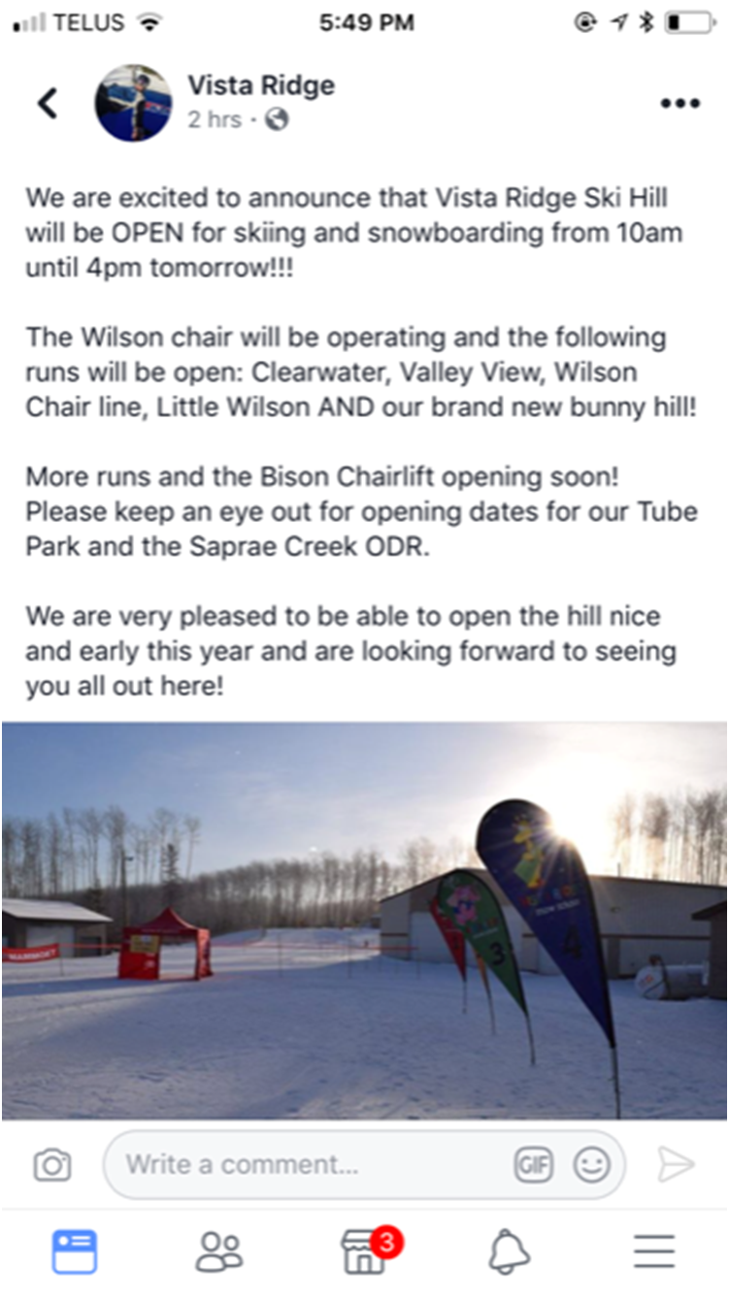

Willow Lake News Regional Municipality of Wood Buffalo April 2013

The vista Ridge Ski Hill is Open for Business!!!

**Skiing/Snowboarding/Tubing**

The Wilson chair lift is operating with the following runs:

Clearwater Wilson Chair line

Valley View Little Wilson

\*\*\*Also featuring: the Brand New Bunny Hill\*\*\*

Stay tuned for the Bison Chairlift will soon be opening!!!

For more information check out our website @:

vistaridge.ab.ca





Willow Lake News Regional Municipality of Wood Buffalo April 2013

Fort McMurray Airport

Fort McMurray Airport

Willow Lake News Regional Municipality of Wood Buffalo April 2013

[](http://ca.images.search.yahoo.com/images/view;_ylt=A0S0uD54991QzlMAzZftFAx.;_ylu=X3oDMTBlMTQ4cGxyBHNlYwNzcgRzbGsDaW1n?back=http://ca.images.search.yahoo.com/search/images?p%3Drecycle%26n%3D30%26ei%3Dutf-8%26fr%3Dfptb-hpd10-s%26tab%3Dorganic%252)MUNICIPALITY NEWS

MARCH2018

Garbage & Recycle Schedule





March 2nd, 2018



March 9th, 2018



March 16th, 2018



March 23rd, 2018



March 31st, 2018

# Community Calendar

|  |  |  |  |  |  |  |
| --- | --- | --- | --- | --- | --- | --- |
| Sun | Mon | Tues | Wed | Thurs | Fri | Sat |

|  |  |  |  |  |  |  |
| --- | --- | --- | --- | --- | --- | --- |
|  |  |  |  | 1 | 2 | 3 |
| 4 | 5 | 6 | 7  Hub  10:30-11am  Yoga  7:30-8:30pm | 8 | 9 | 10 |
| 11  Daylight Saving Time | 12 | 13 | 14  Hub  10:30-11am  Yoga  7:30-8:30pm | 15 | 16 | 17  ST. PATRICK’S DAY |
| 18 | 19 | 20  Spring Begins | 21  Hub  10:30-11am  \*\*Board Meeting\*\* | 22  Calendar Deadline | 23 | 24 |
| 25 | 26 | 27 | 28  Hub  10:30-11am  Yoga  7:30-8:30pm | 29 | 30  GOOD FRIDAY | 31 |

MONDAY NIGHTS: Saprae Creek Volunteer Fire Department Practices.

Willow Lake News Regional Municipality of Wood Buffalo April 2013

\*\*\* Board Meeting\*\*\*

March 21st 7:30-9pm