rmwb_horizontal_reverse.airmwb_horizontal_reverse.ai

SAPRAE CREEK NEWSLETTER

WARD 3

January 2018

**www.rmwb ca**

 2017  2018



**Ward 3 News**

Editor: Joanne Clark

Phone: 780-714-0316

Email: [joanne.clark@rmwb](mailto:joanne.clark@rmwb)

February Newsletter Deadline:

January 25, 2018

Subscribe to your newsletter @

[www.sapraecreek.com](http://www.sapraecreek.com)

Check us out on FACEBOOK

Saprae Creek Residents Society



Municipal Switchboard

1-800-973-9663

RCMP

780-788-4000

By-Law/Animal Complaints: 780-788-4200

Pulse Line: 780-743-7000

Fish & Wildlife: 780-743-7200

SPCA: 780-743-8997

Health link: 811

For Septic Services: Call Andrew March @

Day Time :780-799-5617

After Hours: 780-598-3997

**All EMERGENCIES 911**

# SAPRAE CREEK RESIDENTS SOCITY

215 Freestone Way

Fort McMurray Alberta

T9H5B4

Contact Information

RMWB Notices

Councillor Report

Vista ridge

Airport

RMWB News

Community Corner

Community Calendar

# Inside this Issue

# Contact Information



AnnMarie Hintz, Chair 780-881-2958

Tracy Unger, Vice Chair 780-743-3660

Tanya Poulin, Secretary 780-715-6867

Marilyn Rustad, Treasurer 780-715-4960

Keith Finnson, Infrastucture 780-799-0230

Brittany Lanetti, Youth Director 780-881-4061

Erin Fleming, Rec Director 780-799- 1808

Jennifer McQueen, Municple Contact 312-622-5172

**Email: sapraecreek@gmail.com**

**Lorem ipsum dolor sit amet, consectetur adipiscing elit. Maecenas fringilla hendrerit rhoncus. Donec commodo accumsan metus sit amet pellentesque.**

Praesent volvutpat pellentesque enim, ac gravida arcu gravida non. Suspendisse potenti. Integer vel accumsan diam, sed tristique arcu. Maecenas gravida aliquam dolor, in auctor augue tincidunt et. Vestibulum ante ipsum primis in faucibus orci luctus et ultrices posuere cubilia Curae; Nullam dignissim elit tortor, ac vestibulum massa dictum quis. Aenean vehicula varius lorem, nec condimentum turpis euismod eu. Integer porta ligula ut vulputate porttitor. Curabitur accumsan et ipsum in consectetur. Suspendisse eget diam elementum, scelerisque lectus a, tincidunt felis. Phasellus pharetra sodales fermentum.

Praesent volutpat leo id mauris fringilla tempus. Nulla facilisi. Pellentesque habitant morbi tristique senectus et netus et malesuada fames ac turpis egestas. Pellentesque imperdiet pretium ipsum, eget ornare turpis vehicula at. Donec non bibendum ligula, at accumsan nunc. In orci elit, viverra at semper quis, blandit ac tellus. Ut semper tortor mi, vitae sollicitudin eros ultrices vitae. Nam sagittis orci lectus, pretium sagittis ipsum pulvinar a. Aenean accumsan lectus eu pulvinar sagittis. tristique senectus et netus et malesuada fames ac turpis egestas. Pellentesque imperdiet pretium ipsum, eget ornare turpis vehicula at. Donec non bibendum ligula, at accumsan nunc. In orci elit, viverra at semper quis, blandit ac tellus. Ut semper tortor mi, vitae sollicitudin eros ultrices vitae. Nam sagittis orci lectus, pretium sagittis ipsum pulvinar a. Aenean accumsan lectus eu pulvinar sagittis. tristique senectus et netus et malesuada fames ac turpis egestas. Pellentesque imperdiet pretium ipsum, eget ornare turpis vehicula at. Donec non bibendum ligula, at accumsan nunc. In orci elit, viverra at semper quis, blandit ac tellus. Ut semper tortor mi, vitae sollicitudin eros ultrices vitae. Nam sagittis orci lectus, pretium sagittis ipsum pulvinar a. Aenean accumsan lectus eu pulvinar sagittis. tristique senectus et netus et malesuada fames ac turpis egestas. Pellentesque imperdiet pretium ipsum, eget ornare turpis vehicula at. Donec non bibendum ligula, at accumsan nunc. In orci elit, viverra at semper quis, blandit ac tellus. Ut semper tortor mi, vitae sollicitudin eros ultrices vitae. Nam sagittis orci lectus, pretium sagittis ipsum pulvinar a. Aenean accumsan lectus eu pulvinar sagittis. tristique senectus et netus et malesuada fames ac turpis egestas. Pellentesque imperdiet pretium ipsum, eget ornare turpis vehicula at. Donec non bibendum ligula, at accumsan nunc. In orci elit, viverra at semper quis, blandit ac tellus. Ut semper tortor mi, vitae sollicitudin eros ultrices vitae. Nam sagittis orci lectus, pretium sagittis ipsum pulvinar a. Aenean accumsan

FORT MCMURRAY INTERNATIONAL AIRPORT





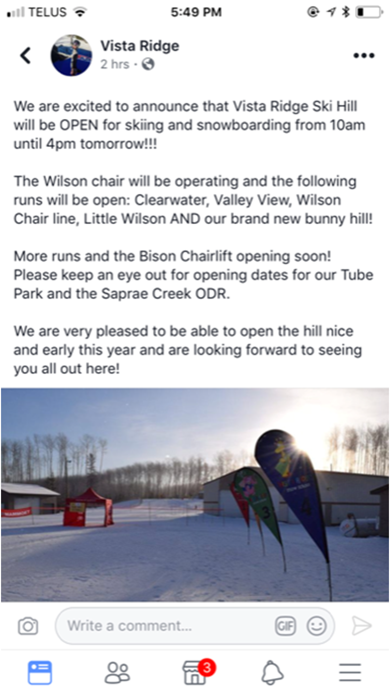

# Vista ridge News



The vista Ridge Ski Hill is Open for Business!!!

**Skiing/Snowboarding/Tubing**

The Wilson chair lift is operating with the following runs:

Clearwater Wilson Chair line

Valley View Little Wilson

\*\*\*Also featuring the Brand New Bunny Hill\*\*\*

Stay tuned for the Bison Chairlift will soon be opening!!!

For more information, check out our website:

@vistaridge.ab.ca





**THE HUB Parent/Child Program**

WHEN : Wednesdays

WHERE : Vista Ridge, Spruce Valley Room

TIME : 10-11 :30

Geared towards ages 0-5, a great way for your child to socialize with similar aged children in Saprae Creek by way of interactive stations and craft time, followed by a light snack.

NO Program Dec 27th and January 3rd 2018

This is such a great program for families in Saprae when your oldest child(ren) is in school and you want to get the chance to get out of the house once a week and meet some fantastic people in our community.

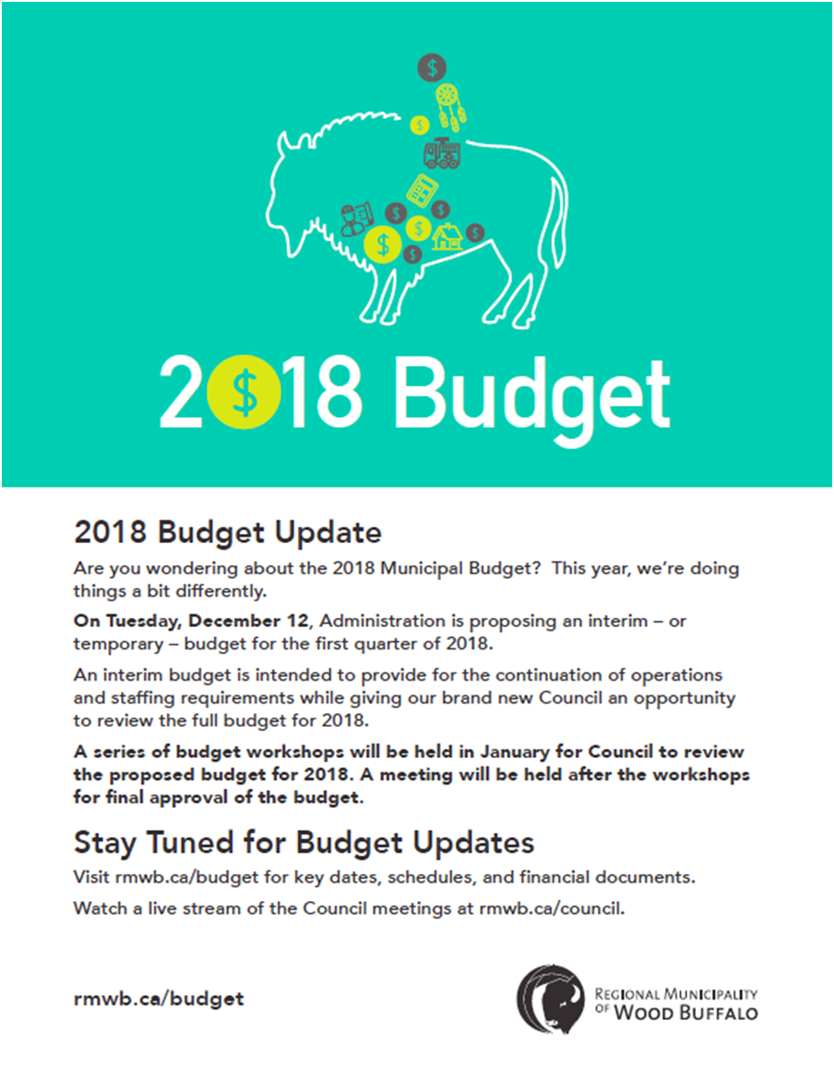

[](http://ca.images.search.yahoo.com/images/view;_ylt=A0S0uD54991QzlMAzZftFAx.;_ylu=X3oDMTBlMTQ4cGxyBHNlYwNzcgRzbGsDaW1n?back=http://ca.images.search.yahoo.com/search/images?p%3Drecycle%26n%3D30%26ei%3Dutf-8%26fr%3Dfptb-hpd10-s%26tab%3Dorganic%252)

January 6th (Dark Blue)

January 12th (Light Blue)

January 19th (Dark Blue)

January 26th (Light Blue)

MUNICIPALITY NEWS

JANUARY 2018

GARBAGE &

RECYCLE Schedule

SCHEDULE

Willow Lake News Regional Municipality of Wood Buffalo April 2013

Willow Lake News Regional Municipality of Wood Buffalo April 2013

Willow Lake News Regional Municipality of Wood Buffalo April 2013

# Community Calendar

|  |  |  |  |  |  |  |
| --- | --- | --- | --- | --- | --- | --- |
| Sun | Mon | Tues | Wed | Thurs | Fri | Sat |

|  |  |  |  |  |  |  |
| --- | --- | --- | --- | --- | --- | --- |
|  | 1  Happy New Year!! | 2 | 3 | 4 | 5 | 6 |
| 7 | 8 | 9 | 10  HUB  10:30-11am  YOGA  7:30-8:30pm | 11 | 12 | 13 |
| 14 | 15 | 16 | 17  HUB  10:30-11am  YOGA  7:30-8:30pm | 18 | 19 | 20 |
| 21 | 22 | 23 | 24  HUB  10:30-11am  YOGA  7:30-8:30pm | 25  **Calendar deadline** | 26 | 27 |
| 28 | 29 | 30 | 31  HUB  10:30-11am  YOGA  7:30-8:30pm |  |  |  |

**Mondays Nights:** Saprae Creek Volunteer Fire Department Practice.

\*\*\*BOARD MEETING\*\*\*

January 24th 2018

7:30-9pm